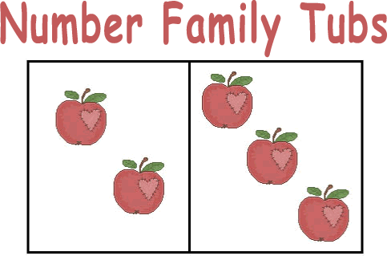
2+3 =5 5-2=3
3+2 =5 5-3=2
Number Families by KGursky©
Please feel free to link to this site and use all materials contained to help children understand and master the addition and subtraction facts. Do not copy materials and place them on your site. The contents of this site were created by me many years ago when I became frustrated over the lack of materials available to help students practice and learn the basic addition and subtraction facts. These materials have been shared and used in my district for over 20 years. The Internet now makes it possible to reach more children and teachers. After much consideration, I have chosen to share these materials, rather than to market them. I have spent many, many hours preparing these materials for the Internet. Respect for my time is appreciated.
Kathy Gursky
First Grade Teacher and Workshop Presenter
www.theschoolbell.com
The Number Family Tubbing system was designed to help students master the basic addition and subtraction facts. Rather than memorizing hundreds of isolated facts, students learn the facts by understanding and applying sound mathematical concepts and patterns. This is not to say that some memorization is not required to learn the facts, but it is not the primary tool used to accomplish the goal.
Number families 5 through 18 are studied in class. A Number Family is a given number, its partners (2 numbers that add up to the number), and all of the addition and subtraction facts that can be generated from the partners. A child working on the Number Family of 8 would be studying and learning the partners and all of the corresponding addition and subtraction facts for 8. The timed test would consist of these facts, plus a review of previously studied facts.
Example:
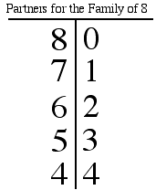
Math facts for the number family of 8
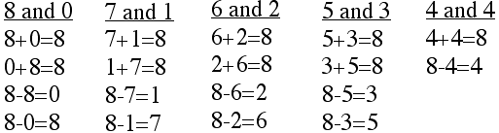

For Number Families 11-18, the highest partner number is 10. For example, 12 and 2 would not be included in the Family of 14 because 12 is higher than 10. Partners over 10 are not included because place value is used to compute such problems. The addition and subtraction facts that are generated in the Number Family system include all of the facts that students need to use when adding and subtracting 2, 3, 4+ place numbers.
View all of the facts 5-18 here.
The following is a list of all of the partners that are included in the Number Families 5 through 18. . Students can learn how to make make their own "t-bars" to help them learn the partners and to see the patterns and relationships between the numbers.
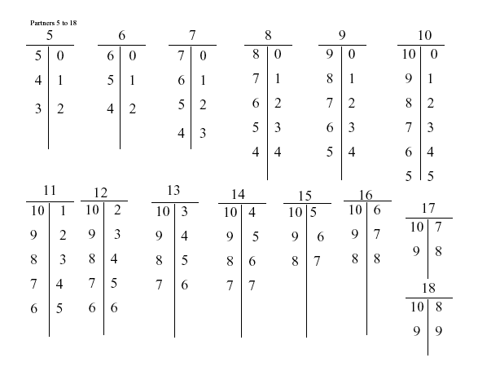
Before testing students to place into Number Family Tubs, they should:
- Understand the concept of addition and subtraction
- Know how to solve unfamiliar addition and subtraction problems
- Know the pre-facts with automaticity: +-0, +-1, doubles to 10, a number
away from itself
- Have a firm understanding of what a number family is
- Know how to find the partners for a given number
- Know how to generate the addition and subtraction facts for the partners in a family
- Know how to use the Tub activities
- Know how to organize materials and turn in completed work
When students are ready to begin Number Family Tubs, they are tested and placed into the appropriate Number Family. Each student receives a small packet of worksheets/activities designed to help him/her learn his/her Number Family. When the packet is complete, the child works in the "tub" for his/her number. There is a tub for each of the numbers 5 through 16. 17 and 18 share a tub because they are studied at the same time. Each tub is filled with games, flashcards and practice activities designed to help the student master the Number Family and pass onto the next number.

